Hello All,

I’m spreading the word about Kathryn Sollmann’s book, ***Ambition Redefined: Why the Corner Office Doesn’t Work for Every Woman & What to Do Instead***.

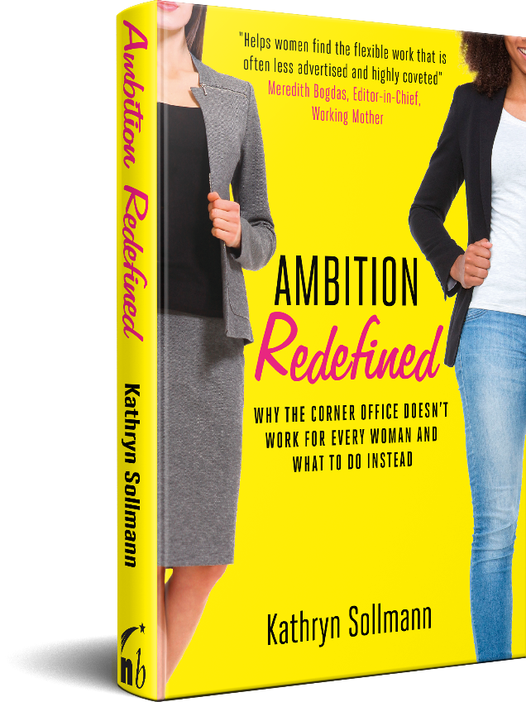Here’s are two great reviews of her book:

“Life is more complex than the usual arguments about women and work make it out to be. ***Ambition Redefined*** challenges assumptions both that it’s impossible to do challenging work while raising a family and that if you’re not gunning for the C-Suite, you’re letting down the sisterhood. Sollmann is reassuring that work need not be all or nothing, but she’s also advancing this radical notion that will change women’s lives: earning money is part of caring for a family. We serve our families by fitting some sort of paid work into our lives, every step of the way.” —**Laura Vanderkam, mother of four and author of *I Know How She Does It* and *Off the Clock: Feel Less Busy While Getting More Done***

“The literary love child between Betty Friedan’s *The Feminine Mystique* and Leslie Bennett’s (spot-on and surprisingly controversial) *The Feminine Mistake.* In ***Ambition Redefined*** Kathryn Sollmann says the unsayable: It’s not mere power that we need to help women achieve at work, it’s the power to engage in consistent workplace participation. So forget trying to figure out whether to ‘lean in’ or ‘lean out’. Instead read ***Ambition Redefined*** and learn how to sway, how to flex your career, so you can blend money and meaning together in the proportions that create the life you really want to live.” **—Manisha Thakor, CFA, CFP, Founder of MoneyZen.com and author of *On My Own Two Feet: A Modern Girl’s Guide to Personal Finance***

Read about [Kathryn](https://www.kathrynsollmann.com/about/), [her book](https://www.kathrynsollmann.com/book/) and her great [pre-order benefits](https://www.kathrynsollmann.com/ambition-redefined-book/).

Please keep the **#AmbitionRedefined** campaign building! Within 24 hours (ideally), copy this message into a new email and send to at least five friends, family members or colleagues who are struggling to find ways to blend work and life. Women at home looking to return to work, or women on the corporate fast track wishing they could find a way to lean in-between.

Kathryn’s book has the answers!

Let’s make sure lots of women know about this great resource.

Best,